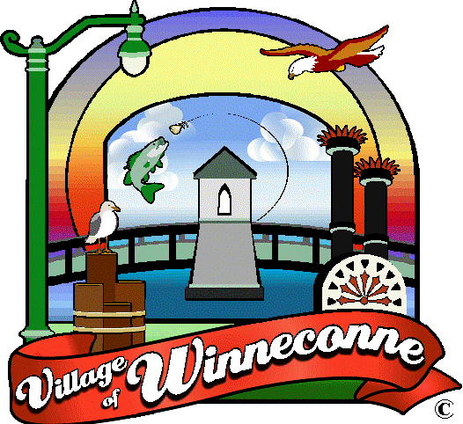
VILLAGE OF WINNECONNE
The Community of Opportunity
30 South 1st Street • P.O. Box 488 • Winneconne, WI 54986-0488
920-582-4381 • www.winneconne.gov

Possible Quorum Notice
Village of Winneconne
Christmas Party
Thursday, December 18th, 2025
5:00pm
Village Pub
235 West Main Street
Winneconne, WI 54986

A Quorum of the Winneconne Village Board Members may be present. Pursuant to Wisconsin Statute 19.84 (2) and (3) notice is hereby given to the public and the media that two or more members of the Village Board of the Village of Winneconne, are expected to attend the event scheduled to be held as noted above. For purposes of the Open Meetings Law only; attendance at a meeting by three or more Board members constitutes a meeting, pursuant to Badke Vs. Village Board of Village of Greendale, 173 Wis2d 553, 494 NW2d 408 (1993), and must be noticed as such, although it is not contemplated that any formal action will be taken at this meeting.

